Staff Ride Walk Book

Task Force Normandy

17 January 1991

____________________________________________________

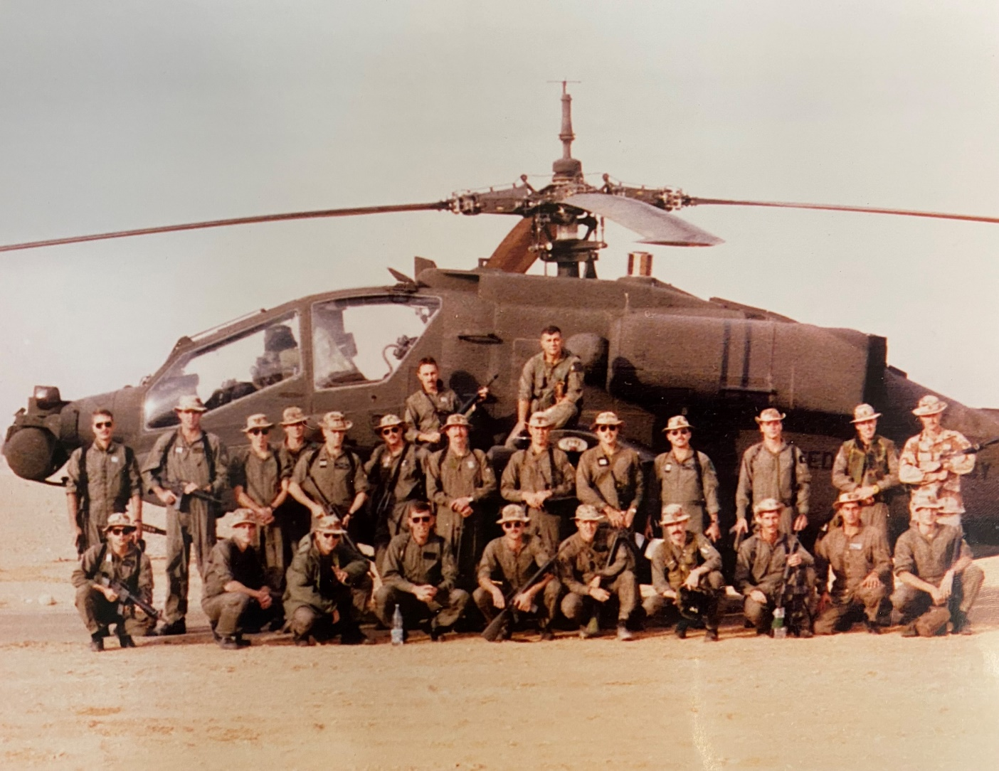

Army University Press

Combat Studies Institute

Fort Leavenworth, Kansas 66027-6900
15 September 2021

____________________________________________________

PAGE INTENTIONALLY LEFT BLANK

Instructor Notes - Task Force Normandy

Instructions: Instructors should read through the read-ahead documents before attempting to read these notes to fully understand the scenario.

These notes contain the detail and analysis of each stand to be used by the instructor. They describe both the talking points of the slides and those used during the virtual view.

Each stand is broken into a Description and Analysis section. The analysis can be done throughout each stand of the staff ride, or it can be left until the end of each stand based on the instructor’s preference.

Slides. When it is time to change the slide, you will see the visual number and title in bold text that is highlighted in yellow. Visual 1-1: Background

Some of the slides are animated. Each “Click” represents a build on the slide when it is viewed in the “slideshow” mode. These builds are activated by a click of the mouse or remote and are annotated in this document by a bold red “Click #” highlighted in yellow.

Quotations. Quotations that are found within the instructor’s notes that could provide additional information of a particular section will be highlighted in yellow.

Virtual View. Movement is important in the virtual view as it gives the students a three-dimensional perspective. Movement instructions are shown in bold green text. Movement instructions are minimal to allow the instructor the flexibility to move where / how he or she wants to go.

Notes for the Instructor. There may be some notes for the instructor within the notes. When there are, they will be in bold orange text and underlined. The instructor does not have to follow these suggestions, but they are there to assist.

Questions. There are questions throughout the staff ride you can ask the students. All the questions will be in bold blue text and italicized. There are some potential answers provided for some of the questions and they will be in normal blue text and italicized. You do not have to use any of these questions, the instructor can ask different questions depending on the training objective or the participation level of the students.

It is best to project the slides and the virtual view on separate screens, side by side. However, it is possible to teach on one screen and switch back and forth between the two views. It does not matter which side the slides or the virtual view is at, set it up however the instructor is comfortable with.

Virtual Staff Ride (VSR) Timeline
Stand | Duration | Time |  | Notes
 | (minutes) | Start | Finish
Link-Up with Unit Online Prior to Start of VSR | 30 | 0830 | 0900
1. Intro / Background | 10 | 0900 | 0910
2. Mission Planning | 5 | 0910 | 0915
3. Pre-Mission Prep | 20 | 0915 | 0935
4. Movement / Actions on the Objective | 15 | 0935 | 0950
5. Post-Mission | 10 | 0950 | 1000
6. Integration | ~15 | 1000 | UTC

Order of Battle - Task Force Normandy
17 January 1991

1st Battalion, 101st Aviation Brigade
Commander: Lieutenant Colonel Richard A. Cody

20th Air Support Squadron (USAF)
Commander: Lieutenant Colonel Richard L. Comer

Task Force White (Western Radar Site)

Pave Low 1:
Capt. Corby Martin / Capt. Bill Lemenager

Pave Low 2:
Capt. Benjamin Pulsifer / Capt. Penny Woodson

Apache 1:
CW2 Brian Stewmon / LTC Richard Cody

Apache 2:
CW2 Tim Zarnowski / 1LT Thomas Drew (Flight Lead)

Apache 3:
CW2 Lee Miller / CW2 Ron Rodrigues

Apache 4:
CW2 Thomas O’Neal / CW3 David Jones

Task Force Red (Eastern Radar Site)

Pave Low 1:
Capt. Mike Kingsley / Capt. Mike Beard

Pave Low 2:
Maj. Robert Leonik / Lt. Col. Richard Comer

Apache 1:
CPT Newman Shufflebarger (Flight Lead) / CW2 Tim Roderick

Apache 2:
WO1 Jody Bridgforth / CW3 Jim Miller

Apache 3:
WO1 Tim Vincent / CW2 Shawn Hoban

Apache 4:
CW2 Jerry Orsburn / CW4 Lou Hall

PAGE INTENTIONALLY LEFT BLANK

Slide 1 - Introduction / Title Page

A. This is where the instructor introduces himself / herself and provides a quick background for the students. If there is anyone else assisting with this staff ride, the instructor can introduce them as well. What is below is only an example, so this can be tailored however the instructor wants.

B. There are three phases to any staff ride: the preliminary study phase, the field study phase, and the integration phase. You completed the preliminary study phase by reading and reviewing the read-ahead packet prior to today. This is the field study phase where we will take you through what happened and try to provide you with some additional information or a different way to look at how things happened.

C. As we go through this scenario, remember, you already know what happens and how this ends, so it can be easy to point out what someone did or didn’t do right. Keep in mind that you need to place yourselves in the various positions during the scenario knowing only what the participants knew at that point in time and from there, decide what decisions could have been made.

D. This is discussion based, we are here to facilitate. We can take this discussion just about anywhere, so please feel free to ask questions.

E. At this end of this staff ride, we will go into the integration phase. That is the “so what” to the things that happened and then we will attempt to see how those things can be applied today.

Q: So, why are we doing this staff ride, why study history?

- Americans are notoriously ignorant about their own history.

- Frederick the Great said that he preferred to learn from the mistakes of others than of his own.

- Humans tend to learn more from bad things than from good.

F. Today we are going to look at Task Force Normandy. The task force consisted of eight Army AH-64A Apache helicopters working with four Air Force MH-53J Pave Low helicopters. The TF conducted a deep attack into Iraq to destroy two early warning sites to blind the Iraqi’s air defense system prior to commencing the air campaign. US forces had to destroy the early warning sites simultaneously to avoid alerting the air defense system. TF Normandy meticulously planned and conducted many rehearsals to mitigate risk during their deep attack and signaling the beginning of the air campaign and OPERATION DESERT STORM.

PAGE INTENTIONALLY LEFT BLANK

Slide 2 - Agenda

A. Here is the agenda that we are going to cover today.

B. We will quickly discuss the strategic background of OPERATION DESERT SHIELD / DESERT STORM, talk about planning for the mission as well as the preparation for it, the movement to the Intermediate Staging Base (ISB) and onto the targets.

C. Finally, we will discuss actions on the objective, the Battle Damage Assessment, and how the Task Force Normandy mission fit into the overall air campaign plan.

So, are there any questions before we begin?

PAGE INTENTIONALLY LEFT BLANK

Stand 1: Background

Visuals: 1-1 - Background
1-2 - Road to War
1-3 - 101st Locations Prior to Deployment
1-4 - 101st Airborne Division Deployment

Orientation:

- None.

- No virtual terrain used during this stand.

Description:

Visual 1-1: Background

A. So, let’s take a look at some of the factors that resulted in Desert Shield / Desert Storm.

Visual 1-2: Road to War

Q: So, what were some of the reasons Iraq invaded Kuwait in August 1990?

A. After its eight-year war with Iran concluded in August 1988, Iraq was deeply in debt and internal tensions were rising. Iraq’s debt to Kuwait alone was approximately $14 billion. Iraq pressured Kuwait to forgive the debt, but Kuwait did not.

B. Kuwait had once been a part of the Ottoman Empire's province of Basra, which Iraq now claimed, making Kuwait a rightful Iraqi territory.

C. Iraq also accused Kuwait of exceeding its OPEC quotas for oil production. Kuwait was overproducing in part to recoup losses caused by the Iran–Iraq War. That caused oil prices to drop, resulting in Iraq losing $7 billion dollar a year in revenue.

CLICK 1

D. In early July 1990, Iraq complained about Kuwait's behavior and openly threatened to take military action. On the 23rd, the CIA reported that Iraq had moved 30,000 troops to the Iraq-Kuwait border.

Q: What was Kuwait’s response to the movement of Iraqi troops to its border?

- In spite of the tone of the Iraqi rhetoric, Kuwait did not mobilize its forces. The Kuwaiti army stood down on 19 July and during the actual Iraqi invasion, most Kuwaiti military personnel were on leave.

E. On 2 August 1990, the Iraqi Army invaded and occupied Kuwait, a move that met with almost immediate international condemnation and brought economic sanctions against Iraq by members of the UN Security Council.

F. Within 12 hours, most resistance had ended within Kuwait, and the Kuwaiti royal family had fled, allowing Iraq to control most of Kuwait. After two days of intense combat, most of the Kuwaiti military was either overrun by the Iraqi Republican Guard or escaped to Saudi Arabia.

CLICK 2

Q: What was the reaction of the United Nations to this invasion?

Possible answers could be diplomatic, informational, military, and/or economic.

- Resolution 660 condemned the invasion and demanded a withdrawal of Iraqi troops from Kuwait.

- Resolution 661 placed economic sanctions on Iraq.

- Resolution 665 authorized a naval blockade to enforce the sanctions.

- Resolution 678 gave Iraq until 15 January 1991 to withdraw from Kuwait and empowered states to use “all necessary means” to force Iraq out of Kuwait after the deadline.

G. The US and UK deployed forces into Saudi Arabia, urging other countries to do the same.

H. On 8 August, the first American units began their deployment to Saudi Arabia.

Visual 1-3: 101st Locations Prior to Deployment

A. On 10 August, the Army issued deployment orders for the 101st. At that time, many of the division’s units were far from their home station at Fort Campbell.

CLICK 1

- Some units were supporting Reserve Component annual training or conducting training exercises at West Point.

CLICK 2

- Others were deployed in Honduras

CLICK 3

- and Panama.

CLICK 4

- Still others were preparing to deploy to the Sinai as part of the Multinational Force and Observer (MFO) mission.

- All units had to return to Fort Campbell as quickly as possible to prepare for the mission in Saudi Arabia.

Visual 1-4: 101st Airborne Division Deployment

A. Operation Desert Shield was the code name for the buildup of troops and defense of Saudi Arabia and Operation Desert Storm was the code name for the combat phase.

B. CENTCOM’s initial objective was to bring enough ground, air, and sea power into Saudi Arabia to demonstrate America’s commitment to defend its ally and deter an Iraqi attack into sovereign Saudi territory.

C. This was a very rapid deployment for the division.

D. Within 5 days of receiving the deployment order, the division’s advance party arrived in Saudi Arabia preparing for the arrival of the rest of the division.

E. CENTCOM placed a high priority on receiving anti-armor equipment, and the 101st’s attack helicopters, the division’s best anti-tank weapons, were sent first.

- The first planes carrying personnel and equipment from the 101st’s Aviation Brigade and the 2d Brigade’s "ready" battalion left Fort Campbell on 17 August.

- Over the next thirteen days, the 101st Division sent 117 helicopters, 487 vehicles, 123 equipment pallets, and 2,742 troops into the theater.

F. The remainder of the division’s equipment moved by convoy and rail to Jacksonville, Florida to be loaded on ships bound for Saudi Arabia. The first ship sailed on 19 August and the last on 10 September.

G. Throughout September, division elements flew to Saudi Arabia; all deploying elements of the 101st were in Saudi Arabia by 6 October; 57 days after receiving the deployment order.

Q: How did XVIII Airborne Corps plan to use the initial forces from the 101st?

- XVIII Airborne Corps planned to use the 101st Division to slow the considerable armor formations that would support any Iraqi thrust into Saudi Arabia.

H. A limited number of roads would be available to invading Iraqi tanks, and the 101st’s ground and air elements could cover these routes.

I. Each of the division’s organic and attached attack helicopter battalions had eighteen AH-64 Apaches or twenty-one AH-1 Cobras providing the 101st with exceptional anti-tank capabilities.

J. The 1-101st Aviation initially fell under control of the 82d Airborne and began patrolling the northern border area of Saudi Arabia.

Analysis: Already completed during this stand.

Stand 2: Mission Planning

Visuals: 2-1 - Mission Planning
2-2 - Mission Development
2-3 - Determining the Correct Mission Force
2-4 - Task Force Normandy Mission

Orientation:

- None.

- No virtual terrain used during this stand.

Description:

Visual 2-1: Mission Planning

A. While LTC Cody and his battalion were out patrolling along the Saudi Arabia / Iraq border area, the CENTCOM planners were developing options for potential offensive operations.

Visual 2-2: Mission Development

A. Iraq’s vital infrastructure – its communication and transportation network – was enclosed by a radar “fence”, protected by a territorial buffer and a screen of ground forces.

B. The Iraqis were only able to establish this defense system through powerful electronic warfare radars that provided essential enemy air threat information regarding size, direction of attack, and speed of any enemy force.

C. If a task force could destroy several of those EW sites, it could cripple Iraq’s capability to integrate its air defense system against coalition air forces.

D. The radar sites were about forty miles apart, with overlapping arcs of radar coverage. Knock out three adjoining sites, and a hundred bombers could pour through. Knock out two and the gap narrows to the minimum necessary. Knock out only one and the overlapping coverage of the adjoining sites filled the gap.

E. Staff planners targeted three Iraqi EW radar sites positioned near the proposed air attack corridor. The sites had to be destroyed at the same time to prevent any warnings or alerts going to the larger Iraqi air defense system.

F. The CENTCOM planners knew that conventional aircraft or cruise missiles could do the job, but without eyes on the site to assess the extent of the damage, the allies would have no way of knowing whether the targets were truly destroyed or not.

G. However, the use of helicopters was considered the best option “because the pilots could loiter on station, assess damage, and reengage targets until they were sure nothing was left.”

Visual 2-3: Determining the Correct Mission Force

A. According to then-Lt. Col. Richard Comer, the 20th Air Support Squadron Commander, around the middle of September, Colonel Jesse Johnson, CENTCOM’s Special Operations (SOCCENT) Commander and Comer’s Wing Commander, Colonel Gray, had told General Schwarzkopf that the MH-53J Pave Lows had a navigation system built around GPS and that Comer’s Pave Lows had it installed.

Pave Low Capabilities:
- Rear hydraulic ramp for loading/off-loading troops, vehicles and supplies;
- 2x 450 gallon external fuel tanks extends range to 900 km or 540 miles;
- For CSAR missions (their primary mission during Desert Storm), they had Personnel Location Systems (PLS) to home in on downed pilot beacons;
- Doppler terrain following / avoidance radar – nap of the earth or low-level flying;
- Forward Looking Infra-Red (FLIR) pod - allows all-weather, day / night flying;
- GPS / Inertial navigation systems - pinpoints the helicopter precise location, anywhere on the globe;
- 3 gun ports with 7.62mm miniguns and/or M2 .50cal machine guns;
- Secure radio communications.

Apache Capabilities:
- Two T700 engines with large Black Hole IR-suppressing exhaust systems;
- Rotor blades designed to withstand 23mm hits;
- Airframe can withstand ballistic impact of shots up to 12.7mm caliber;
- TADS/PNVS (Target Acquisition and Designation Sight/Pilot's Night Vision System) that combines a low-light level TV, laser designator and forward-looking infra-red;
- IHADSS (Integrated Helmet and Display Sighting System) provides a monocular helmet-mounted designator/sight;
- 1x 30mm cannon with 1200 rounds;
- 16x Hellfire Anti-Tank Missiles;
- 19 shot pods with Hydra-70 unguided rockets.
B. The next day, Colonel Gray and Comer’s Group Commander, Colonel Orrell, told him about the potential tasking and Comer replied immediately that “the Pave Low only had side-firing 50cal machine guns and lacked the firepower to prevent messages going out from the sites prior to knocking out their communications gear.”

C. Orrell and Gray then asked Comer if the Apaches should be brought in. The Apaches, as Comer understood them, had the range and more than enough firepower.

D. The next day, Comer met with LTC Dick Cody. “I told him the specified tasks of the mission. He was immediately enthusiastic and hot for the mission. His confidence and his detailed description of his aircraft capabilities were real assets.”

E. The AH-64 Apache could carry a mix of weapons that could assure destruction of both hard and soft targets. “After we met, Colonel Orrell asked me if putting these two aircraft together was the way to go and I said yes.”

E. By 25 September, the CENTCOM planners had refined their plan. Colonel Johnson, called in COL Tom Garrett, the 101st Aviation Brigade Commander, and LTC Cody.

F. Colonel Johnson outlined a joint force of Army and Air Force helicopters - Apaches and Pave Lows - that would infiltrate into Iraq to destroy radar and ground-control interception sites.

G. The mission concept was that the Pave Low helicopters would lead and navigate using their GPS technology and the Apaches would follow them to the release point and then move on to their objectives.

H. The Pave Lows would also be available for a search and rescue mission should any Apache aircraft get shot down.

I. Cody stated that it could be done, but would need to use more than Hellfire missiles to be successful. They would also need flechette rockets and a full load of .30mm ammo for the chain gun.

Visual 2-4: Task Force Normandy Mission

Q: What was the initial mission for Task Force Normandy?

A. The initial mission was for LTC Cody and his task force to strike and completely destroy three early warning radar sites in western Iraq to open up a twenty-mile-wide air corridor for coalition jets to use in the bombing of Baghdad.
Q: Why was the destruction of those radars important?

- The radars were located along the route that EF-111 electronic warfare planes would use to jam for the F-117s and other coalition aircraft headed to bomb Baghdad.

- By taking out those two sites, Baghdad had no early warning,” (then-Major Robert) Leonik said. “By the time they could react, it would be too late.”

B. Some of the other mission factors were:

- The early warning radar targets were just north of the Saudi-Iraqi border.
- The sites were separated by approximately 40 miles of open desert.
- Intelligence estimated the Iraqi radars could look as far as 150 miles into Saudi territory at medium and high altitude and 30 miles at low altitude.

Analysis: Already completed during this stand.

Stand 3: Pre-Mission Prep

Visuals: 3-1 - Pre-Mission Prep
3-2 - Team Selection
3-3 - Training
3-4 - TF White Target Site
3-5 - Training
3-6 - Interoperability
3-7 - Final Mission Update Brief
3-8 - Movement to the ISB
3-9 - Final Mission Update Brief

Orientation:

- None.

- Orientation will be done just prior to using the virtual terrain.

Description:

Visual 3-1: Pre-Mission Prep

A. While given approval from COL Johnson to start planning in late September, it wasn’t until early October that the 101st Commander, MG Peay, consented for Cody to train with SOCCENT, even though the raid remained a when and if contingency.

Visual 3-2: Team Selection, Training, and Interoperability

A. After receiving the initial approval from COL Johnson, LTC Cody begin planning for the covert strike into Iraq on 26 September 1990.

B. One of the first things LTC Cody had to do was to determine who was going to be a part of the task force.

Q: If you were the commander, how would you chose your team for this mission?

- Would you take everyone from a single company?
- Would you cherry pick from across the battalion?
- Or would you select battle rostered crews?

Q. What are the pros and cons of each possible method?

CLICK 1

C. There were three considerations that kept Cody from using a single company:

  - First, the company selected would be split out and isolated from the battalion, with the consequent hard feelings in the other companies.

  - Second, this was something Cody wanted spread out as much as possible.

  - Third, all the casualties would be suffered by one company.

D. If Cody cherry-picked experienced individuals from across the entire battalion, he would be creating new two-man flight crews that would need time to get used to working with each other, no matter how great they were individually.

E. Cody stated, “There’s a tendency, for a special mission like this, to make “all-star” crews: take the best individual pilot and put him with the best individual copilot-gunner. I didn’t think that was the best way, and I don’t think so now. It’s a matter of working together, knowing each other. That only comes from a lot of experience as a crew.”

Q: How did LTC Cody finally decide on who would take part on this mission?

- He selected battle rostered crews, crew members that flew together regularly. This decision applied to the maintenance teams as well, as they would be an integral part of the task force and forward deployed up until mission launch.

Q: Why was that important?

- Battle rostered crews flew together regularly. Cody said “I slotted myself to lead one of the three-ship teams. Automatically, that meant (CW2 Brian) Stewmon, my copilot-gunner on the battle roster, was going too. You never break up a crew unless they don’t work well together.”

Q: If you were the commander, how would you chose your team for this mission?

F. After the first training mission for the TF Normandy attack, the crew selections were verified. The pilots selected to conduct the original mission were then formed into three teams of three Apaches; Red Team, White Team, and Blue Team.

CLICK 2

Q: How do you mitigate the risk of unexpected changes to the mission or selected personnel?

- You can continually “what if” the mission to ensure that if anything changes, you have thought through that contingency.
- Always need to assess the risk and have ways to mitigate them.

- You need to be ready to voice those concerns to higher if you cannot mitigate a risk down to a safe level.

A. Once the teams were selected, that was supposed to be it. Unfortunately, during a pick-up football game, one of the chosen pilots tore his ACL.

Q: What happens when you need to replace one of the pilots for personal or medical reasons?

- The pilot has to be replaced, but not just him, his co-pilot has to be replaced as well (remember, battle-rostered teams were the standard).

- You need to quickly get the new team up to speed with the training that has already taken place.

- Cody: “Weeks’ injury was worse because I had to drop him from Normandy. It looked like we’d have to bring in a substitute crew and make another tough selection - but just about then the blue site went off the scope.” Now with only two targets, TF Normandy had four Apaches and a pair of Pave Lows for each target.

CLICK 3

B. Originally there had been three teams, Red, White, and Blue, and three targets - all Iraqi radar sites - in the mission plan. But Blue team’s target was taken off the mission list early in December 1990, about the same time as the pilot’s injury.

Q: How did that impact the operational concept for this mission?

- It allowed the three helicopters assigned to Blue Team to be reassigned; one went to Red team, one to White team, and the third became the spare helicopter in case one of the primary birds went down.

C. In this case, these two events actually helped mitigate some of the risk associated with the mission.

Visual 3-3: Training

Q. How do you train for a mission when the team does not know what the mission is?

CLICK 1

A. Operational specifics remained unknown to the pilots, they trained relentlessly, studying intel maps, photos, and sandbox mock-ups of their targets.

B. Once Pave Low light signals, required flying techniques and the speed and altitude of flight were all worked out, the aircrews logged hundreds of miles, always at night and without communication, navigation or formation lights.

C. The AH-64s’ relatively limited range (265 miles) was also a concern. Without some way to top off their tanks, the helicopters wouldn’t have the fuel to complete the mission.

D. The pilots and maintenance crews addressed the problem of the Apache’s range by adding a tear-shaped, 230-gallon external fuel tank beneath one of the Apache’s two stub-wings.

Q: What do you need to get before you are approved to make a modification like that to an Apache?

- An Air Worthiness Release (AWR) is an authorization to fly in a way not covered by regulations. The only place that issued AWRs was Aviation Systems Command (AVSCOM) in St. Louis.

E. Once the AWR was approved allowing the use of the auxiliary fuel tank, the Apache’s range was doubled. So was their operational time because they no longer needed to refuel at a possibly browned out FARP but could instead fly all the way back to a hard stand, so their maintenance problems were greatly reduced.

F. However, with an additional 7500 pounds of fuel on one pylon, the Apache handled quite differently; but, the crews flew with this configuration several times and were comfortable with it well before the actual mission.

Visual 3-4: TF White Target Site

Note that we will be showing the virtual terrain in daylight simultaneously with the PowerPoint slide. Ensure that your tech has the time set for 1200 within VBS.

A. Now we are going to show you what the White Team’s target area looks like in the daylight so you can better understand how the site is laid out and approximately how close the various equipment is to each other.

Virtual View 1 – This is the virtual view of the target area. VBS scenario time settings: 12:00h. Coordinates: 8588.265, 5958.391, 805.418. Move camera to right side of the base and angle it down slightly until you can view the entire base and identify all the equipment.

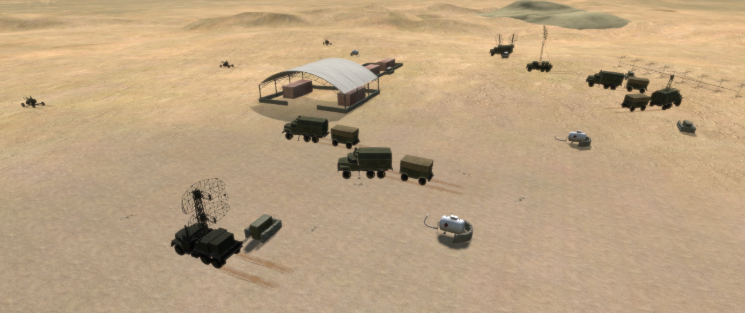

The next nine clicks are based on when you click forward. Make sure you leave enough time between clicks so the students can look at both the slide and the visual terrain to compare should they chose to.

B. Each radar site had a combination of

CLICK 1 a Spoon Rest radar,

CLICK 2 a Squateye radar,

CLICK 3 and a Flatface radar,

CLICK 4 a troposcatter communications shelter and antenna

CLICK 5 generators,

CLICK 6 an operations van,

CLICK 7 an electronic warfare van,

CLICK 8 barracks,

CLICK 9 and 3x ZPU-4 antiaircraft guns.

C. There were also fuel containers and additional trucks with trailers.

D. Each of the Apaches had a primary target, along with another Apache’s primary as a secondary target. Cody arranged primary and secondary targets to assume every piece on the EW site had redundant hits. The intent was to assure that nothing could be easily repaired.

E. The generators were first, then the command bunkers, and finally, the radar dishes themselves. By hitting power sources first, the pilots would silence the radar site before it could alert the Iraqi central control headquarters in Baghdad.

Q. The engagement priority was a deliberate decision, but what risks are there with this?

- By not destroying the ZPU-4s first, there was a risk they could fire on and potentially down one or more of the Apaches.

F. The final configuration for the TF Normandy aircraft was decided to be 1200 rounds of 30mm, one 2.75-inch rocket pod, two Hellfire missile launchers, and one 230-gallon Extended Range Fuel System tank.

G. The concept for the attack was to engage the target with Hellfires at approximately 6 kilometers. After all of the Hellfires were expended, the Apaches were to move to 4 kilometers and started firing Multipurpose Sub-Munitions (MPSM) rockets and at 2 kilometers from the sites, they were to engage with their 30mm chain guns to destroy whatever remained of the compounds until they were out of ammunition.

Visual 3-5: Travel

Q. Does planning and training for a mission in a joint environment bring about any additional challenges? Why or why not?

CLICK 1

A. Joint operations come with some challenges when bringing different services together to work as a team.

B. The Apache and Pave Low crews had never worked together before this mission, and each service had different tactics, techniques, and procedures (TTPs).

C. In practice sessions, the Pave Lows would position the Apaches and then break off to return to the prearranged site. Meanwhile, said Colonel Cody, “we would go on in and practice our attack tactics, how we would sequentially dismember and destroy these sites by sectoring our fire, how we would lay for each other if we had to, how we would fight if one guy got shot down, all the permutations and combinations of “what if?”

D. They learned other valuable lessons, reinforced by good pre-briefs and post-flight hot washes. “We practiced such things as what type of formation flights we wanted to fly,” said Cody. “How low we wanted to fly. How fast we wanted to fly. All of this was done with no [voice communications]. What light signals [would emanate] from the Pave Lows. What techniques to indicate we’re turning; we’re not going to turn.”

CLICK 2

A. OPSEC for the future Task Force Normandy mission was a critical concern to preserve covert training specifics and avoid any suspicion. The majority of the training was done at night, after the completion of the regular duty day.

Q: What kind of OPSEC concerns were there associated with this mission?

- Talk from within other US units, eyes and ears of potential enemy personnel working within the area as janitors, cooks, etc.

Q: What are some ways in which you can counter those OPSEC concerns?

- Limit the number of people who know, be vigilant about who is around when discussing the mission, train at different times than normal, be aware of what you are writing in. How many times have Soldiers inadvertently left their green notebooks somewhere where others could find it and read what was inside?

B. Discussions about the mission were conducted only between those who were cleared and had a need to know.

C. Both Lieutenant Colonel Comer and Lieutenant Colonel Cody conducted all their training almost 700 miles away from the actual objective and the crews never practiced the actual route.

D. In fact, the movement to the actual operational base was classified. The Air Force and Army crews planned to fly separately to the staging base at Al Jouf from King Khalid Military City (KKMC).

Visual 3-6: Interoperability

Q: How would you define “interoperability”?

- According to Army Regulation 34-1: Interoperability, dated 9 April 2020, interoperability is the ability to act together coherently, effectively, and efficiently to achieve tactical, operational, and strategic objectives.

- Interoperability activities are any initiative, forum, agreement, or operation that improves the Army’s ability to operate effectively and efficiently as a component of the Joint Force, within an inter-organizational environment, and as a member or leader of an alliance or coalition across the range of military operations.

CLICK 1

A. In 1983, the US conducted Operation “URGENT FURY” in Grenada and about eight months prior to the start of Desert Storm, the US had conducted Operation “JUST CAUSE” down in Panama. These two operations could be looked at as the first where interoperability came to the forefront.

Q: How well do you think interoperability worked out in those two actions?

- “Interoperability” was an ominous term appearing frequently in after action reports from Grenada and Panama, describing the problems inherent when two or more services try to work together. In those mini-wars, interoperability was rarely better than tolerable, often much worse.

Q: What are some of the areas you think interoperability must be worked out?

- Communications, terminology, encryption, equipment differences, capabilities

CLICK 2

B. According to Lt. Col. Comer “We had to work on our secure radios in order to get the time of day of our frequency hopping UHFs to synchronize. Several of the guys worked that procedure hard and tried several methods out on the flight line with power on before it was solved. Our tactical FMs did okay in this regard. Still, when we executed the mission, the only calls came after the radar sites were burning wreckages.”

C. Additional differences in equipment were that the Apaches operated at night using infrared that needed no ambient light while the Pave Lows used Night Vision Goggles, which required some ambient light.

D. Comer also recalled that they had developed an alternate way to transfer fuel - but it was only to be used in an emergency. “We also jury-rigged a way to pump fuel from a Pave Low on the ground to the Apaches. We had a long fire hose which we could clamp on our fuel dump tubes with a gas tank nozzle at the other end. We tested it and pumped fuel into some barrels to ensure we had something with us in the formation should we encounter a desperate need.”

E. After the completion of one rehearsal flight in late October, the team took the gun camera tape over to COL Johnson to show him the effects. He watched and immediately took the tape over to GEN Schwarzkopf so he could view it as well.

CLICK 3

F. Schwarzkopf had reserved for himself the decision whether or not to use the Apaches. After watching the tape, he looked at COL Johnson and said, “OK. Give ‘em a go. You’re sure they’ll get 100 percent? Is it going to be as smooth as the video?” “There are navigation, range and rescue problems, sir, that we’re just beginning to work on.” Schwarzkopf replied, “Keep me informed.”

Visual 3-7: Desert Flight Challenges

A. Challenges to Flying in the Desert

Q: What are some of the challenges to flying in a desert environment?

CLICK 1

1. There are several things about desert flying that degrade performance. First, the extremely high air temperature means less lift, so you cannot carry much very far.

2. Second, the dust gets into all moving parts - thousands of them - and clogs filters while also causing serious problems with auxiliary power units, environmental controls, and shaft-driven compressors.

3. The fine desert sand eroded the leading edges of rotor blades ten times quicker than normal. When they’re pitted, the whole blade (wing) wobbles, shaking the aircraft like an unbalanced washing machine. To protect rotor blades from erosion caused by airborne sand, a special paint, and later a special tape, was applied the blades’ leading edge.

4. Windscreen covers were tested and purchased. They were particularly important because pitted windscreens affected the ability of the pilots to fly at night. The erosion caused by the blowing sand distorted images in the pilots' night vision goggles and increased the chances of accidents.

5. Crews quickly found that the fine sand was partially transparent to their radars, leading to less than anticipated obstacle clearance.

6. Poor visibility caused by the extremely find sand, kept suspended in the air by relatively light winds, was a particular problem for helicopter crews.

7. Night landings were, by far, the most demanding and required the development of specialized techniques, including the use of small chemical lights as hover points.

CLICK 2

B. Then-Lieutenant Tom Drew said this about the sand: “You have to focus 100% on flying the aircraft every second. If you don't, it could kill you. It was a very challenging environment, and we had a very young Aviation force back then, SO as leaders you must constantly reinforce the basics.

Visual 3-8: Movement to the ISB

A. Task Force Normandy held a final rehearsal on 10 January 1991, and everything went as planned. The rehearsal verified the actual timing and distances involved to identify any errors.

B. Without glancing at notes, Cody talked his team through the run-up for the raid and its execution: a seven hundred mile flight across Saudi Arabia. They would take off from

CLICK 1 King Faud International Airport

CLICK 2 and fly

CLICK 3 to King Khalid Military City to refuel

CLICK 4 and then continue on

CLICK 5 to a small Air Force Special Operations Command (AFSOC) airfield at Al Jouf where Task Force Normandy would at last be shown the targets and routes for their mission.

C. Al Jouf was a joint airfield with a small single runway staging strip, northeast of Tabuk, and it was the closet Saudi airfield to the Iraqi border.
D. They’d stay the night in AFSOC quarters, sleep late because take off for Iraq would likely be around one in the morning of 17 January.

E. If all went well, they’d by back by dawn on the 17th, refuel at Ar Ar and King Khalid Military City (KKMC), and immediately proceed to King Fahd where General Peay would find them ready for duty on 19 January.

F. On 14 January 1991, the Apache teams made their way from the King Faud International Airport to KKMC. The helicopters arrived in radio silence, refueled, and departed as quickly as they could for Al Jouf, doing their best to look like just another training flight.

Visual 3-9: Final Mission Update Brief

A. LTC Cody and Lt. Col Comer did not brief their teams on the particulars of the mission until just prior to the strike.

B. At 2130 on 16 January, Lieutenant Colonels Comer and Cody held a final mission update brief for all the Apache and Pave Low crews.

C. In satellite photos of each site, the teams recognized a well-dispersed assortment of military equipment, trucks, and vehicles.

D. These included low-altitude Squat Eye, high-altitude Flat Face, and older Spoon Rest surveillance and acquisition radars, along with a troposcatter dish for secure communications, and what appeared to be power generators, an operations van, an electronic warfare van, and a barracks.

E. Protecting each site were three ZPU-4 AAA guns, their deadly 14.5mm quad mounted machine guns pointing menacingly at the sky.

F. There really was nothing more to say. All recognized that they were about to take part in a significant event and, while nervous, were extremely confident that they were the right force at the right time and place. All used the short time available before proceeding to their aircraft for private moments, actions, and prayers.

CLICK 1

G. Captain Kingsley felt the gravity of the moment, noting that “I immediately had “butterflies” in my stomach. [I thought,] oh my gosh, the weight of the world is on this mission. A lot of people could die if we fail.” He grabbed Capt. Corby Martin and went over the details of the mission for the “hundredth” time before heading out to the aircraft.
H. H-Hour—the commencement of the air campaign and Operation Desert Storm—was set at 3 a.m. on the 17th, which meant the first of the two groups, Team White, would lift off at 12:56 a.m., followed five minutes later by Team Red. If all went according to plan, both teams would arrive at their destinations at exactly 2:38 a.m.

I. At 2330, crews began pre-flight checks and at midnight they started engines.

Analysis: Already completed during this stand.

Stand 4: Movement / Actions on the Objective

Visuals: 4-1 - Movement / Actions on the Objective
4-2 - Alignment for Mission Execution
4-3 - Mission Overview
4-4 - Captain Martin’s Map
4-5 - Confirming Positions
4-6 - Movement to the Objective
4-7 - Actions on the Objective

Orientation:

- None.

- Orientation will be done just prior to using the virtual terrain.

Description:

Visual 4-1: Movement / Actions on the Objective

A. At 0056 on 17 January 1991, the first helicopters took off from Al Jouf headed toward their assigned targets.

Visual 4-2: Alignment for Mission Execution

A. Captain Corby Martin led Task Force White out of Al Jouf that night, while Lieutenant Colonel Cody led the four White team Apaches close behind. A few minutes later, Captain Mike Kingsley led Task Force Red from Al Jouf, followed by Captain Newman Shufflebarger and the remainder of his team.

B. As they had done in the numerous rehearsals ramping up for this mission, all the helicopters flew with only a three rotor-disk radius of separation between them, no more than a hundred feet above the ground, with no navigation or formation lights, and no communications to their target area.

C. There were also two MH-53s at Ar Ar prepared to conduct any CSAR missions in the area, the primary mission for the Pave Lows.

D. Cody had also brought along an additional AH-64 as a spare and a UH-60 Black Hawk with a Downed Aircraft Recovery Team, or DART, in case something happened to one of the primary Apaches.

Q: What is the difference between CSAR and DART missions?

- According to FM 3-04.513, Battlefield Recovery and Evacuation of Aircraft, CSAR is the successful extraction of a downed aircrew and evacuation of the aircrew either to appropriate medical care or back to the unit.

- A DART team successfully extracts an aircraft from a downed location to a safe location, using aerial recovery kits, trained recovery team, and recovery aircraft.

Visual 4-3: Mission Overview

A. CLICK 1: Here is Task Force White, which will move out to the western site.

B. CLICK 2: Here is Task Force Red, which will move out to the eastern site.

C. CLICK 3: And here is the spare Apache and DART team that will move up to Ar Ar after both task forces had departed. They flew there to be closer to both teams in case something happened.

D. From here, we will just follow TF White as there was no real difference between the two mission sets.

Visual 4-4: Captain Martin’s Map

A. This is the actual map that Captain Corby Martin used while leading Task Force White from Al Jouf to its assigned mission.

B. Just to clarify what the numbers on the map mean, Captain Martin confirmed that:

- CLICK 1 is Al Jouf, where the mission took off from.

- CLICK 2 was a checkpoint.

- CLICK 3 was a checkpoint with a course change.

- CLICK 4 was the last checkpoint prior to crossing the border.

- CLICK 5 is where the green chem light bundles were dropped.

- CLICK 6 is the target location.

- CLICK 7 was a checkpoint after re-crossing the border with a course change.

- CLICK 8 was another checkpoint and course change (Ar Ar is just to the west).

- CLICK 9 was the final checkpoint and course change.

- CLICK 10 was landing at Al Jouf and end of mission.

Q: How were the checkpoints identified? Do you think they were done visually or by a combination of speed, the heading, and direction?

Q: Is one of these methods better than the other or is it mission dependent?

Visual 4-5: Confirming Positions

A. From approximately 40 kilometers out, CW2 O'Neal could make out a glimmer of light near the target. Oblivious to the threat of war, the Iraqis had left the lights on.

B. At 0212, the Task Force Normandy helicopters crossed into Iraq, varying their flight path as necessary to avoid known or suspected enemy observation posts or Bedouin locations.

C. The western target was 13 miles farther; the eastern target, 23 miles.

D. To help the Apaches navigate during their final approach, the Pave Lows would drop a bundle of green infrared chemical lights at a preset point 9 miles from each target. This is point 5 on the map.

E. Visible only through night-vision goggles and forward-looking infrared sensors, the chem lights would enable the Apaches to update their attitude-heading reference systems and remain on course.

F. Right on cue, 90 minutes into the mission, the Pave Lows dropped the chem lights on the designated reference points and moved out as the Apache crews updated their navigation systems and closed in on their respective targets.

Visual 4-6: Movement to the Objective

Note that we will be showing the virtual terrain at night simultaneously with the next two slides. Ensure that your tech has the time set for 1950 within VBS.

A. Now we are going to fly this mission using the virtual terrain. In this scenario, you are in the front seat of the first Apache.

B. The Pave Lows have already dropped the chem light bundles and they have moved off to their stand-by location where the Apaches will link up with them after completion of the mission.

Virtual View 1 – This is the starting point for the virtual terrain. VBS scenario time settings: 19:50h. Coordinates: 8900.307, 2806.667, 790.942.

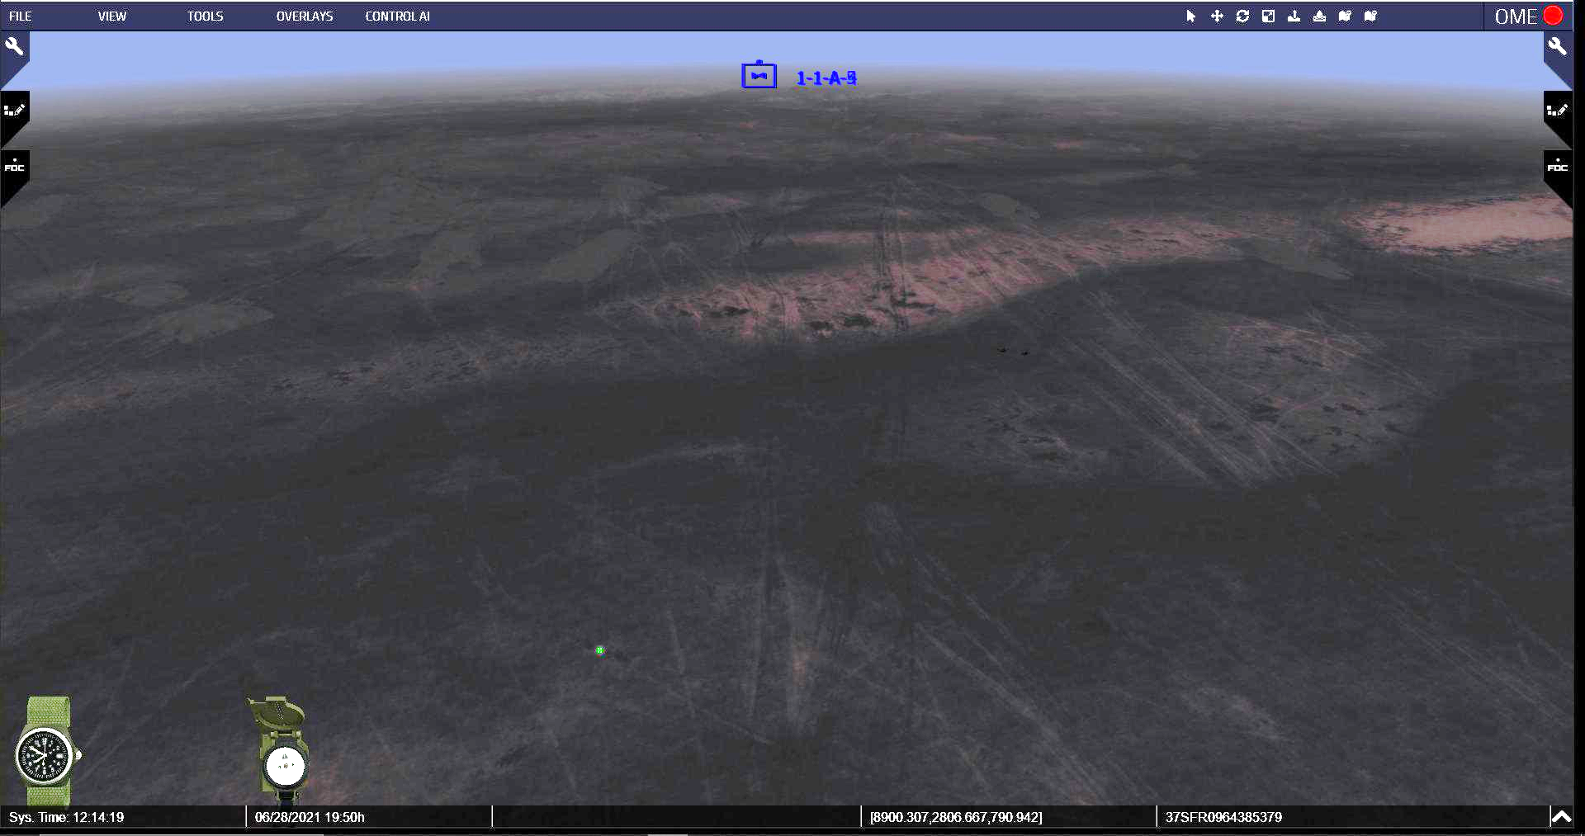

Show this on the virtual terrain.

C. First, the Apaches are going to move up over the chem lights so they can update their attitude-heading reference systems and remain on course.

D. Once they finished updating their guidance systems, the team flew to the east using the terrain to mask their movement.

Virtual View 2 - Fly down to approximately this height on the terrain; then fly ENE to the location center of the circle.

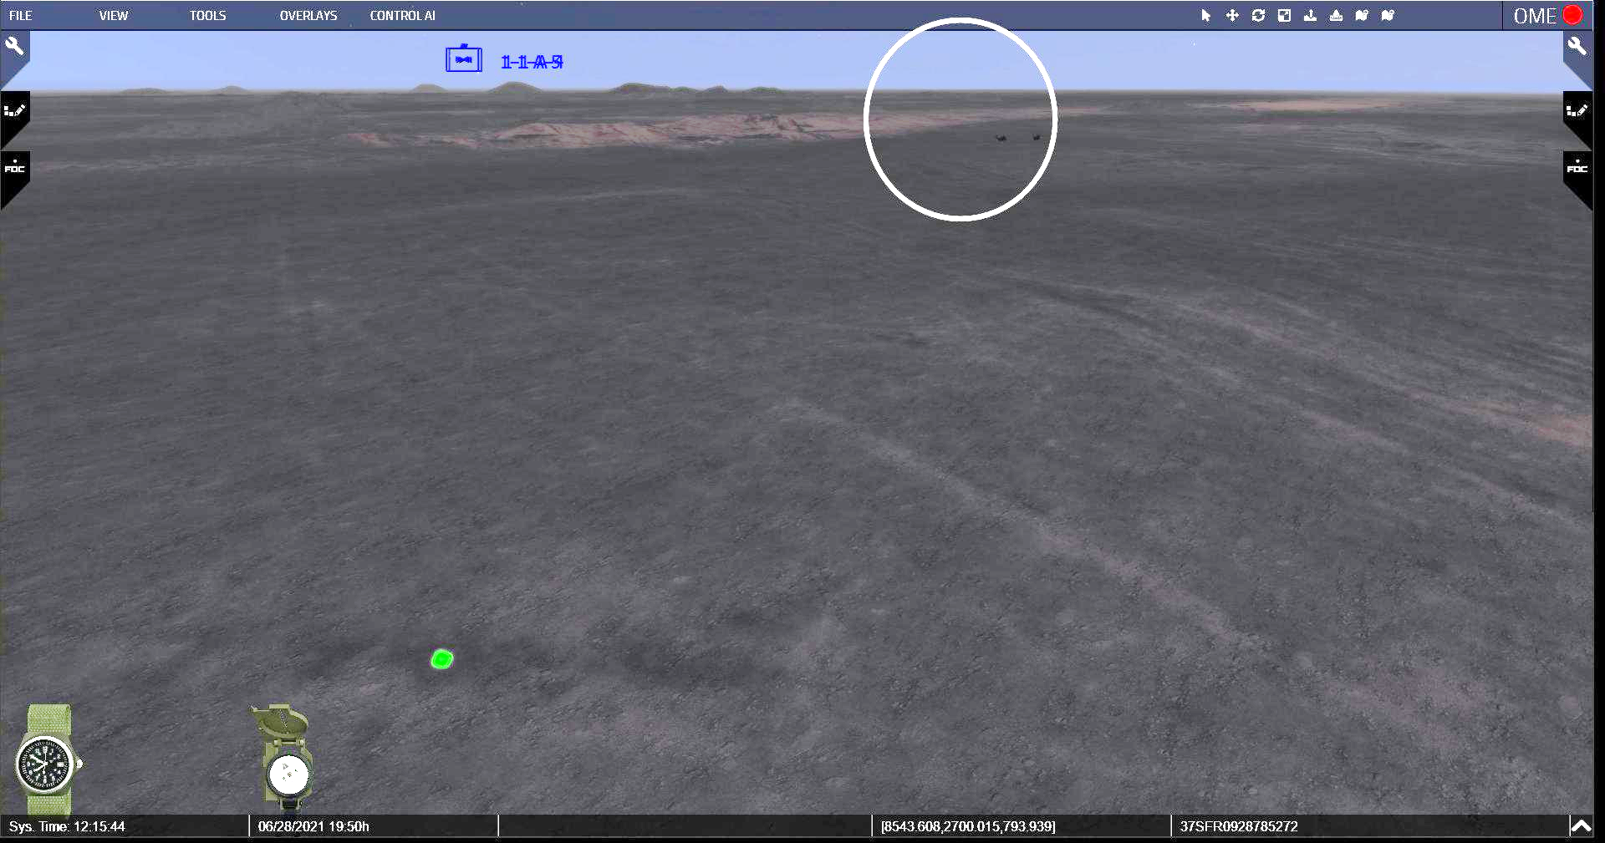

CLICK 1

E. After going east for about 3-5 kilometers, they started to head north – again, utilizing the desert terrain to mask their movement and maintain concealment.

Virtual View 3 - At this point you should be approximately at coordinates: 10223.001, 4352.012, 85.02. Turn the camera, keep the same height and fly straight ahead to the North.

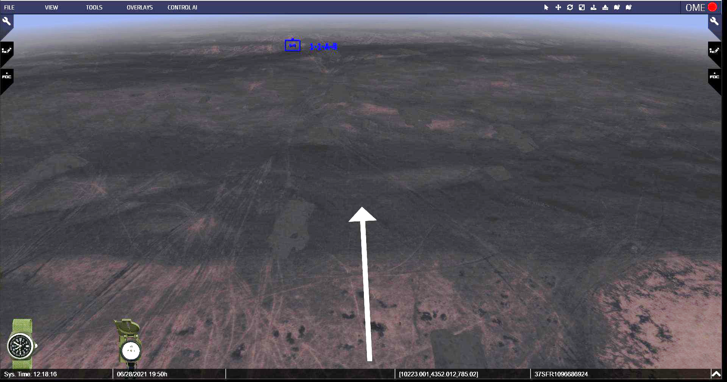
Virtual View 4 - Continue straight until you approach this large sand dune.
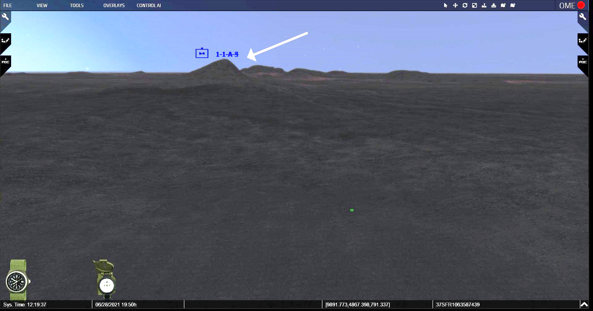

Virtual View 5 - Turn approximately 90 degrees to the left and go around the right side of the large sand dune. Approximate coordinates: 10250.8, 7235.374, 800.114

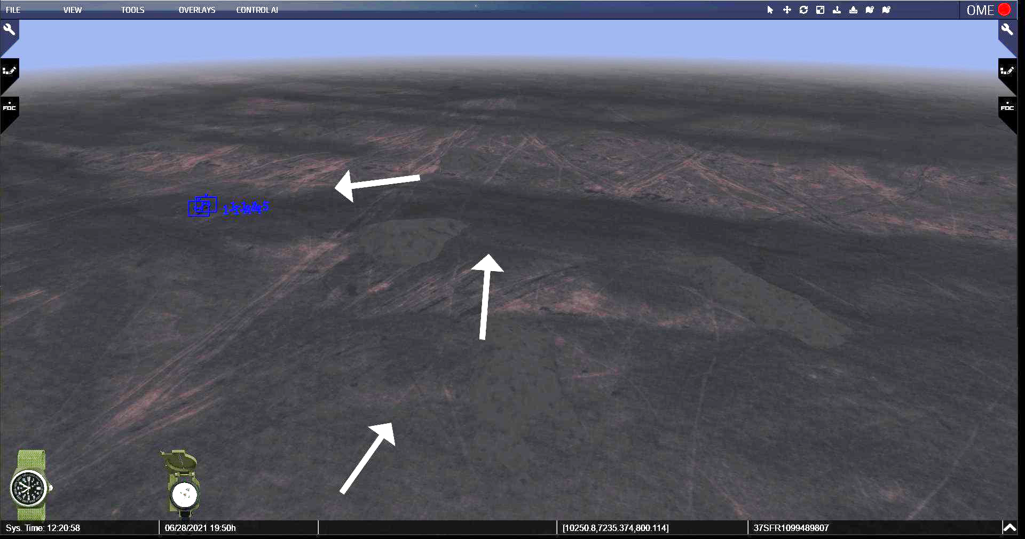

Virtual View 6 - Align camera to this view, coordinates: 9129.067, 7028.924, 799.193 **Camera needs to be on the right side of the 3 Apaches**

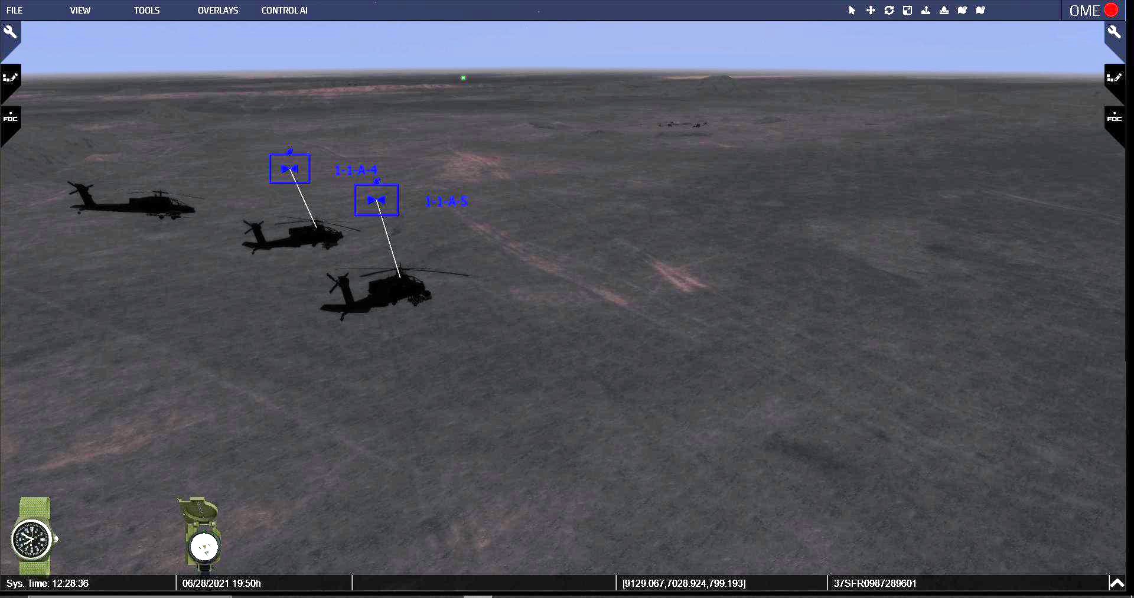

Virtual View 7 - Move the camera and lower the view to match the view on Virtual View 8.

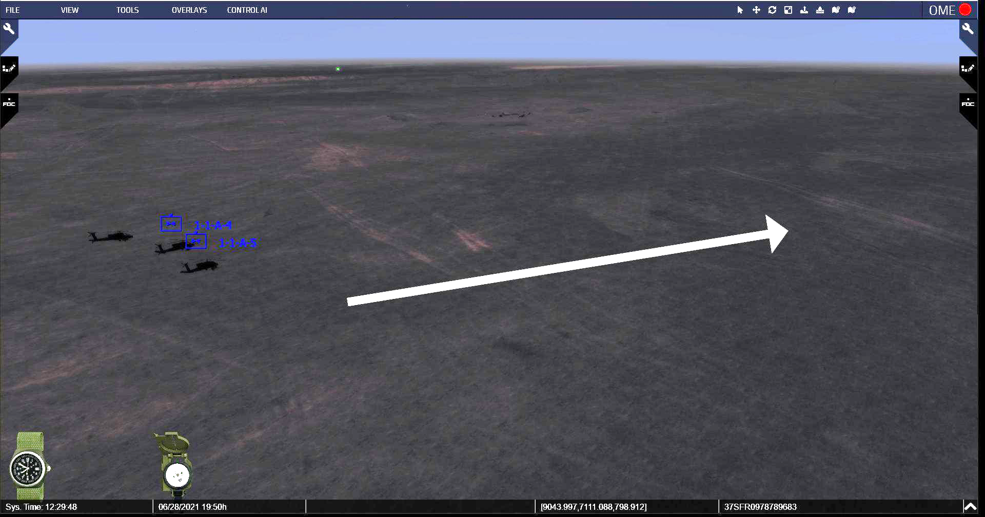

Visual 4-7: Actions on the Objective

Note that we are in the lead helicopter and are moving to the right side of the other three White Team Apaches. The Apaches will still be approximately three rotor blades apart from each other.

Once you start moving forward, you will no longer be able to see the other three Apaches (they remain in a static position due to limitations with VBS).

A. After traveling approximately 5-7 kilometers north, they reached their planned release point, which was northeast of the target site. Coming in from this direction would hopefully help confuse any Iraqis on site who may have seen or heard the Apaches prior to execution.

B. LTC Cody had given LT Drew operational control of White team. Cody was there for the overall coordination of TF Normandy, even though the Red team was forty miles away and beyond his influence.

C. Slipping through the clear, dark night, they pulled into firing position exactly 90 seconds early. At exactly 0237:50, White Team Apache pilot Lieutenant Tom Drew keyed his radio and broadcast, “Party in 10.”

D. Precisely ten seconds later, all crews began firing their Hellfire missiles. Twenty seconds later, the deadly weapons began to detonate against the structures.

CLICK 1

Virtual View 8 - Coordinates here are 8498.669, 7202.606, 795.842. Keep this height and move the camera slowly forward. **You should be pointing south**

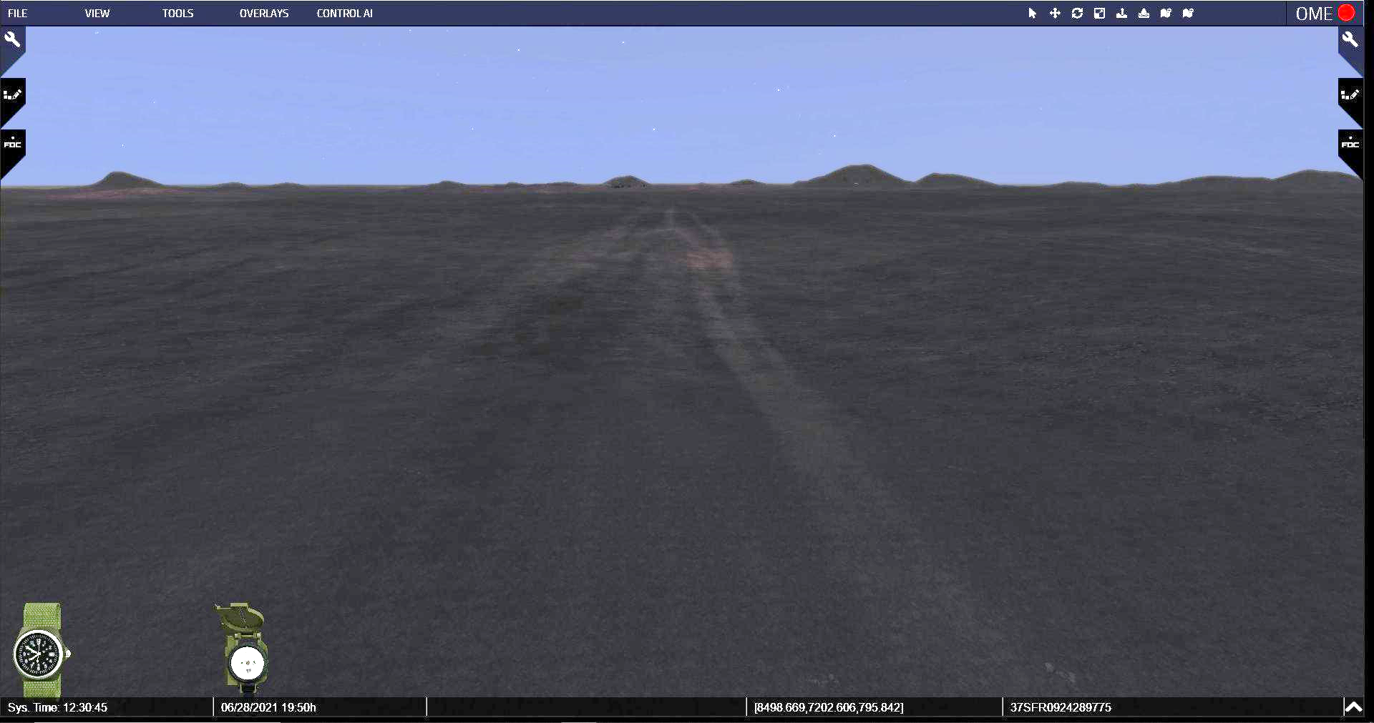
E. After firing their Hellfires, the Apaches moved slowly forward as they began firing their rockets. Once all the rockets were fired, the Apaches then began firing rounds from their chain guns to ensure the complete destruction of the target area.

Virtual View 9 - Move the camera forward until you reach this view, coordinates: 8510.126, 6104.461, 804.981. Then raise camera height and point camera down slowly until you match Virtual View 10.

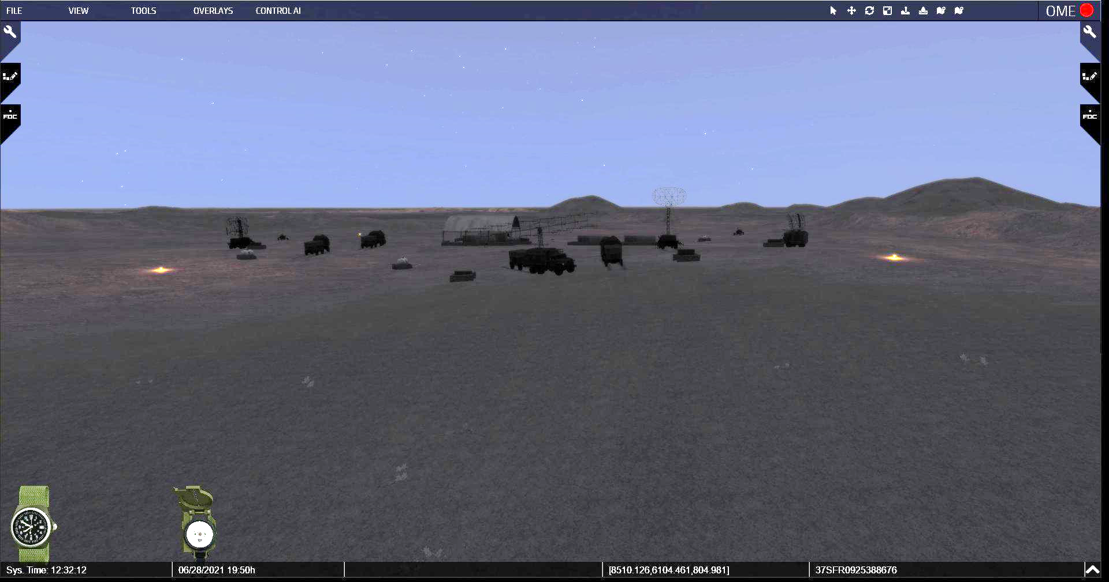

F. The generators were first, then the command and EW control bunkers, and, finally, the radar dishes themselves. Once the Apache crews visually confirmed that the radar equipment was destroyed, they put the ZPU-4 anti-aircraft gun positions under fire.

Virtual View 10 - Hover over the encampment here, approximate coordinates: 8508.031, 6050.795, 807.723.

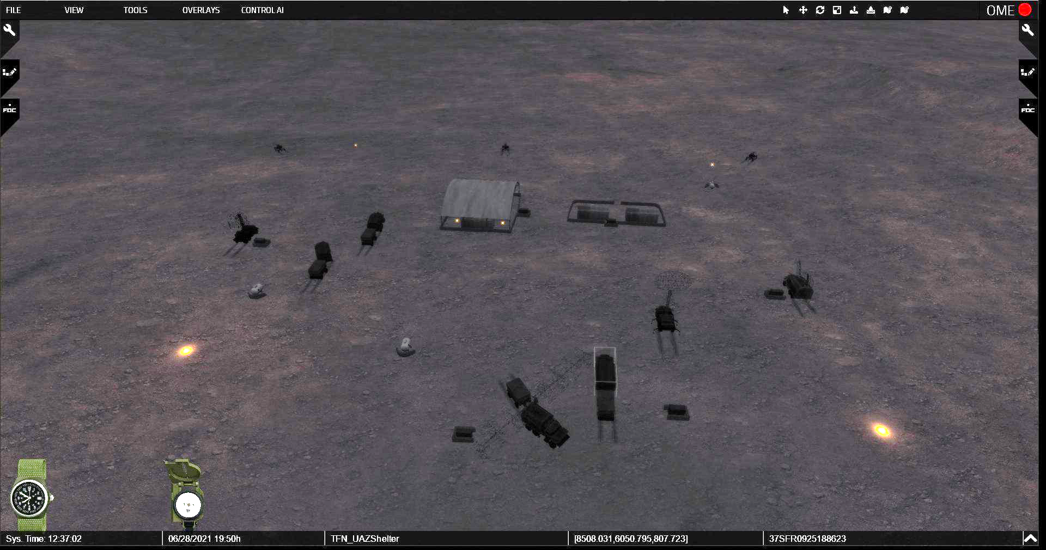

G. The Apaches hovered over the site for a few moments, their cameras recording the deadly results of the mission. Then they turned and proceeded south to link-up with the Pave Lows at the rendezvous point.

H. In just four minutes, the Apaches at both target sites fired all of their onboard Hellfire missiles, flechette rockets, and 30 mm ammunition at their targets and achieved 100% destruction of both enemy radar sites.

I. With the advantage of surprise and violence of action, there was no known enemy reaction to these attacks or reports of ground fire from either site.

Analysis:

Q. What did you think of LTC Cody’s plan before you saw it on the virtual terrain? What do you think of it now?

Stand 5: Post Mission

Visuals: 5-1 - Post-Mission
5-2 - BDA and Mission Impact

Orientation:

- None.

- No virtual terrain used during this stand.

Description:

Visual 5-1: Post-Mission

A. Upon completion of the mission, each team sent their reports to the Pave Lows.

B. TF White transmitted “California A-A”; meaning they had achieved 100 percent site destruction and had no US casualties.

C. “Nevada A-A” was the TF Red report; they had also achieved 100 percent site destruction and had no US casualties.

D. The Apaches then flew south, crossed the border, and linked back up with the Pave Lows, who led the team back to Al Jouf.

Virtual View 11 - When prompted by the facilitator, slightly lift camera and move south.

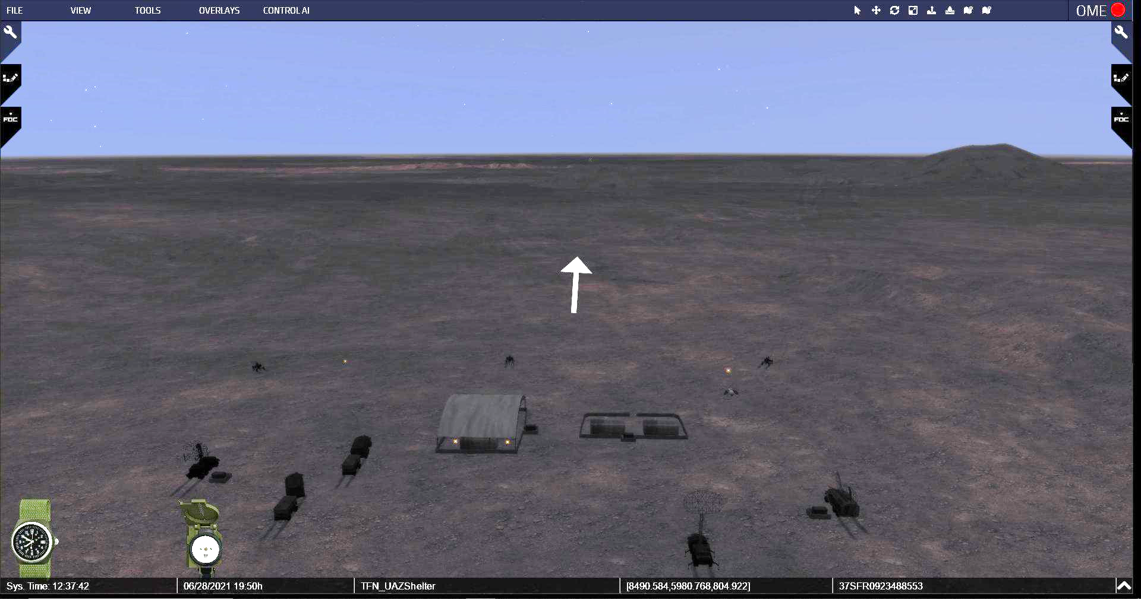
Virtual View 12 - When you arrive at the multiple mini-sand dunes patch (approximate coordinates 8515.765, 4040.525, 788.263), turn the camera left (east), and continue moving towards the Pave Lows.

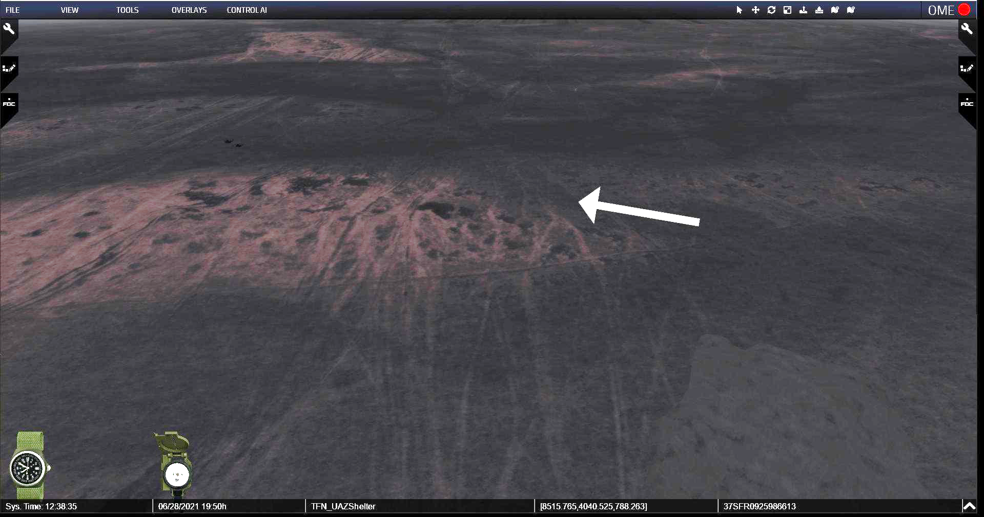

Virtual View 13 - Land the camera slightly above goring level and behind the Pave Lows at coordinates: 9228.288, 3436.051, 787.335

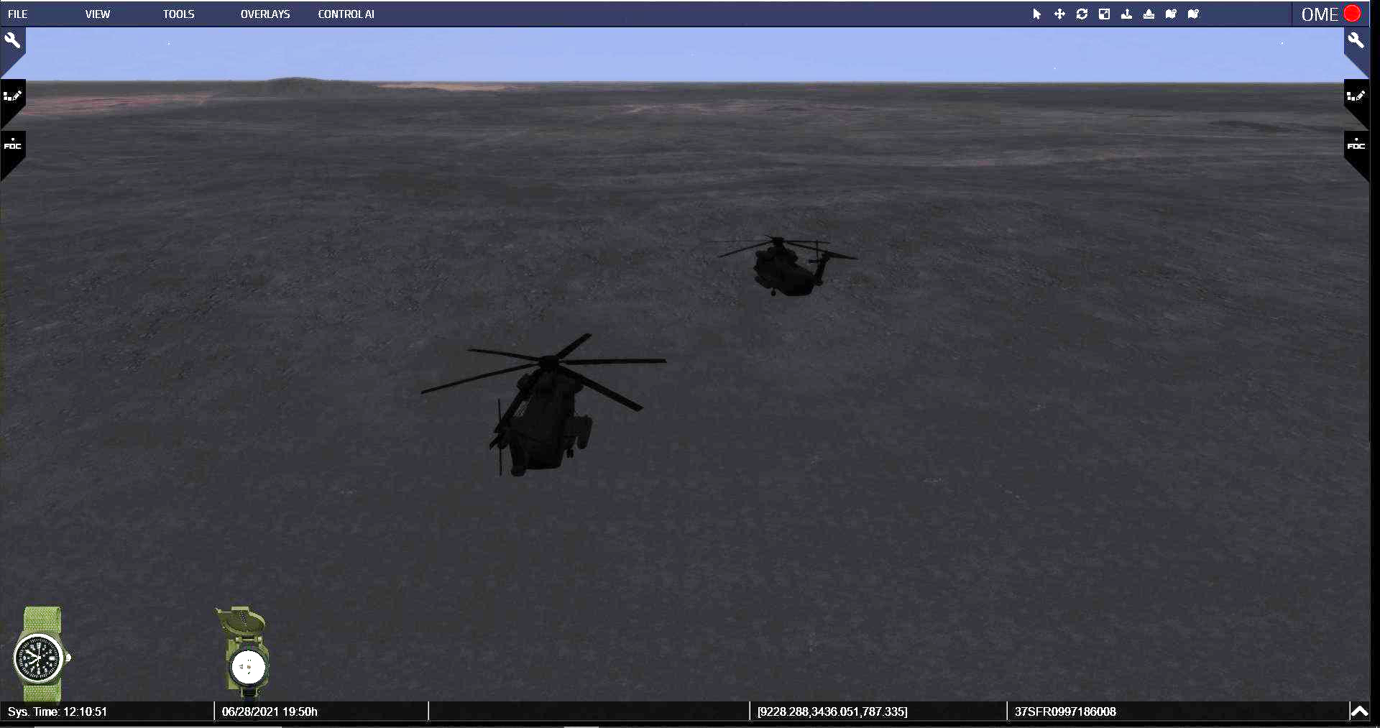

E. The initial return plan called for refueling at Ar Ar, but because so little time and gas was spent over the targets, the Apaches were able to reach Al Jouf where they would refueled, inspected their aircraft, and began the long flight back to Camp Eagle II where they would rejoin the rest of their battalion.

Visual 5-2: BDA and Mission Impact

A. The combination of Pave Lows and Apaches had worked as planned. All the planning, calculating, and training had paid off. The mission was a complete success as the Apaches fully destroyed both early warning radar sites.

B. The search and rescue Pave Lows and the DART that loitered near the border were not needed as the task force lost no aircraft and sustained no casualties.

C. This attack destroyed the two border EW radar sites twenty-two minutes before H-hour and gave coalition aircraft the opening they needed to fly north to Baghdad and drop their munitions.
D. Two days later, on 19 Jan, an AC-130 gunship went to the radar sites to destroy anything left and found nothing left to shoot at.

Q: If the mission had not been successful, would it have necessitated a delay to the start of Desert Storm?

- No, Desert Storm was going to start at 0300 on 17 January regardless of how successful the TF Normandy mission was.

Q: What changes would have to have been made if the radars were still functional.

- According to then-Lieutenant Drew, coalition aircraft would have to drop to a lower altitude as crossed into Iraq and then they would have to determine when they would have to begin to climb so they were at the proper altitude when it came time to drop their ordnance. Once that was complete, they would have to drop back down to the lower altitude as they headed back to Saudi Arabia.

Analysis:

Q: What could have been done better or differently in the execution of the mission?

Q: Could we attempt such as operation today? Defend your answer.

Q: How would we conduct an operation of this type today? Would it need to be a joint operation or a SOF aviation mission?

PAGE INTENTIONALLY LEFT BLANK

Integration

Visuals: Integration

The first two questions are always asked, but all the questions that follow after are just some suggested ones you could use. This is where you could ask questions that help reinforce what the training objectives were for conducting this staff ride or open it up for the students to ask any questions they may have. Encourage crosstalk between the students and let them have that professional discussion between themselves.

INTEGRATION

Q: Did seeing the actions using the virtual terrain help you better visualize what happened? Did it change the way you looked at this action?

Q: So what are your takeaways from this? What was it that really got you thinking as we went through this?

Q: At the time, was this mission defined as a deep attack or a raid? How would it be defined today?

- A raid is an operation to temporarily seize an area in order to secure information, confuse an adversary, capture personnel or equipment, or to destroy a capability culminating with a planned withdrawal.

- An attack is something that destroys or defeats enemy forces, seizes, and secures terrain, or both.

Q: What is the importance of this mission for us today?

Q: What risk did LTC Cody assume by agreeing to use the second fuel tank instead of the FARP? How did he mitigate that risk?

Q: What would the strategic implications have been if this mission was not the total success it turned out to be?

Q: With all of the digital systems within the Apache today, how important is it to continue to train on and maintain proficiency using analog systems?

Berg, Colonel Paul E. and Kenneth E. Tilley. Chapter 8: Task Force Normandy: The Deep Operation that Started Operation Desert Storm, 142.
Richard L. Comer, email to Troy D. Lewis, Army University Press, Fort Leavenworth, KS 66027, 15 March 2021.
Comer, email, 15 Mar 2021.
Comer, email, 15 Mar 2021.
Blair, Kimberly. “Taking Out the Eyes of Iraq.” Northwest Florida Daily News. Website http://www.nwfdailynews.com/archive/news/01/010118news1.html. Site originally accessed on 5 September 2002.
Taylor, Thomas H. Lightning in the Storm: The 101st Air Assault Division in the Gulf War, 84.
Taylor, 81.
Taylor, 135.
BG Thomas R. Drew, email to Troy D. Lewis, Army University Press, Fort Leavenworth, KS 66027, 2 February 2021.
Mackenzie, Richard. “Apache Attack.” Air Force Magazine, October 1991, 58
Mackenzie, 57.
Taylor, 130.
Comer, email, 11 March 2021.
Comer, email, 11 March 2021.
Taylor, 96.
BG Thomas Drew, Microsoft Teams Chat with Troy D. Lewis, Army University Press, Fort Leavenworth, KS 66027, o/a 19 January 2021.
Whitcomb, Darrel D. “On a Steel Horse I Ride: A History of the MH-53 Pave Low Helicopters in War and Peace,” 306.
Corby Martin, email to Troy D. Lewis, Army University Press, Fort Leavenworth, KS 66027, 25 March 2021.
Martin, email, 13 April 2021.

